A Film by PAOLO CONSORTI

- HAVANA KYRIE PRESS KIT 2019

SYNOPSIS
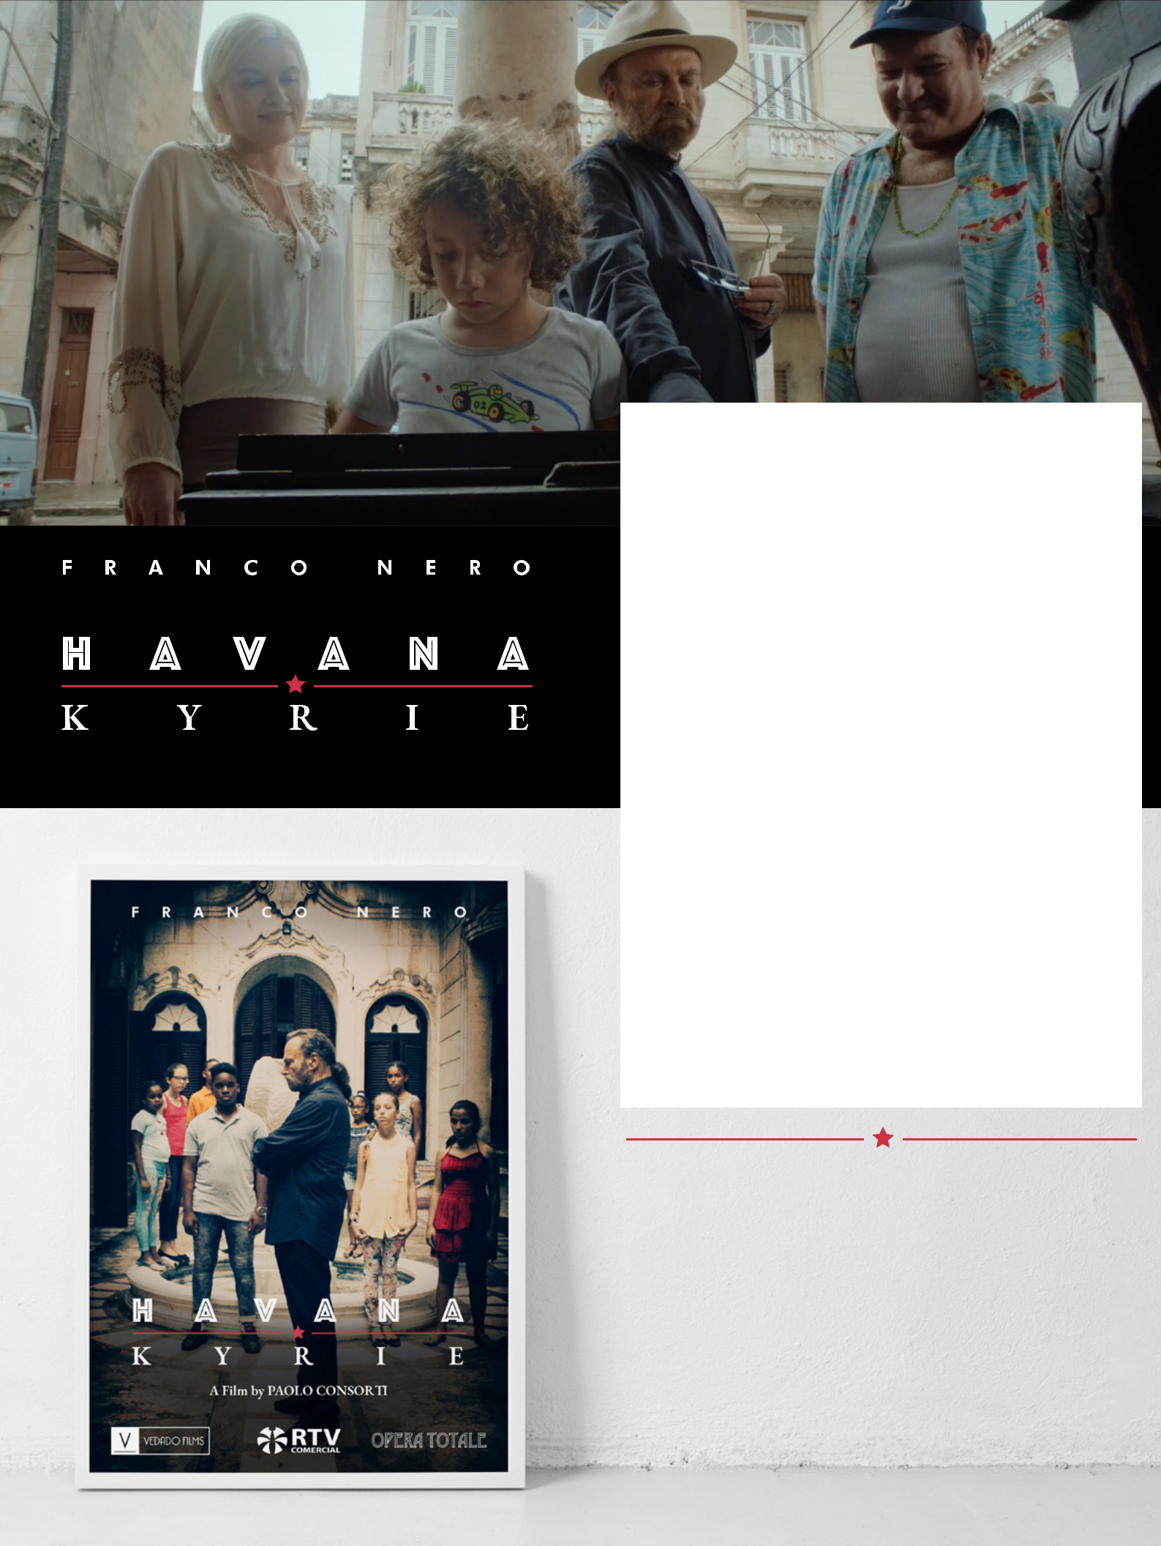
ACuban-Italian feature film set against the ever-marvellous city of Havana, takes you on a heart-

warming, musical journey, in a tale about the pitfalls of pride, the importance of family, the pursuit of passion, the significance of transformation, and the joy of love found.

Franco Nero plays the role of ‘Maestro’ Vittorio Arditi De Bellis - An Orchestra Conductor celebrated as the foremost on the music of Rossini for his masterful interpretations of his work, some say the most impeccable renditions of Rossini’s work. Bravo Vittorio! – You went as far as was possible all the way to the top of your field… But if Vittorio is such a celebrated man, then why does he feel so empty?... Why has he lost his sense of taste? - And where did his passion go?

Vittorio’s masterful renditions of the Rossini-Kyrie will not ‘soften the judges’ – not this time – Now he must swallow his pride and ‘face the music’ - as it were. Finding himself reluctantly on the way to Havana, Cuba, his ego yet to wrangle, he gets off on the wrong foot as expected - and is quickly on the verge of losing everything and everyone again… Until his unexpected past will suddenly add purpose to his future, and so he may, even if only just once again, be able to taste ‘the spice of life’ and love the ones around him.

FRANCO NERO

as VITTORIO ARDITI DE BELLIS

Orchestra conductor and an expert on Rossini.

Vittorio is an ageing, orchestra conductor not long ago celebrated as the foremost master of Rossini. A grumpy old man, he ruins a long and brilliant career on a quirky old man’s tantrum. Now he’s on a last chance mission to save his career - Who will save him from himself?

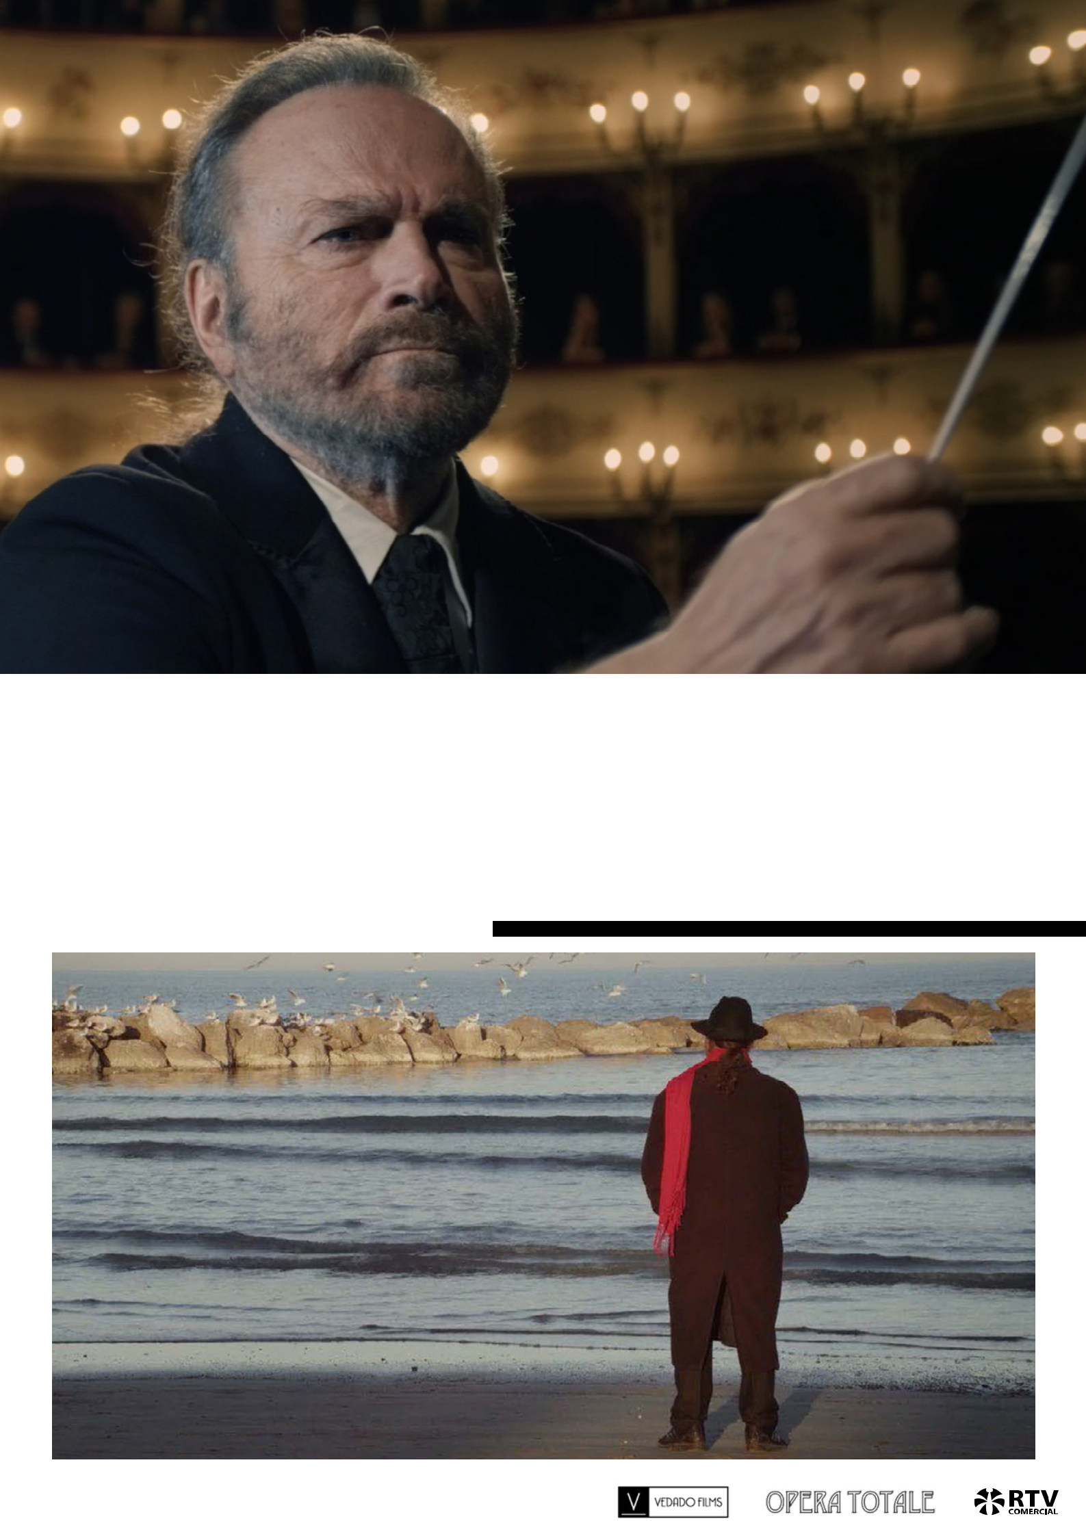

- HAVANA KYRIE PRESS KIT 2019

JORGE PERUGORRIA

as LUCAS

The Maestro’s trusted personal Guide and Driver.

Jorge Perugorría is one of Cuba’s top Actors. His filmography is extensive, he is previously known for his leading role in Strawberry and Chocolate (1993) and Che - Parts 1 / 2 (2008).
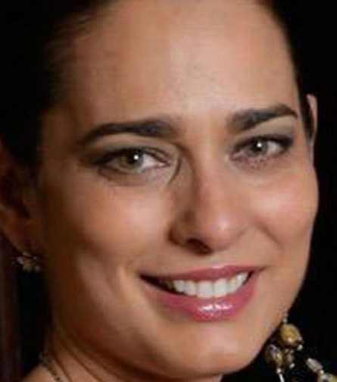

3 HAVANA KYRIE PRESS KIT 2019

YACQUELINE ARENAL
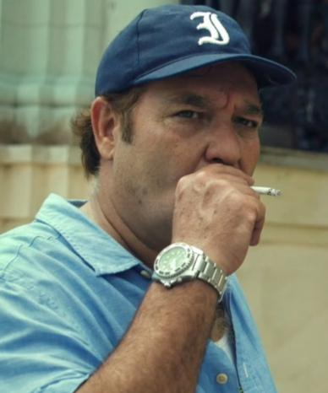

as ISABEL ORELLANES

Vittorio’s ex-girlfriend -hailing from distant past.

Yacqueline Arenal is a well known Cuban actor who has resided in Colombia enjoying considerable success in the Telenovela world.

ANDROS PERUGORRIA

as VICTOR

Victor is Isabel Orellanes’ Son and a buddying performing comedian.

Andros Perugorría is a Cuban actor, son of famous actor and director Jorge Perugorría. He is previously known for Juan of the Dead (2011) and 7 Days in Havana (2012).
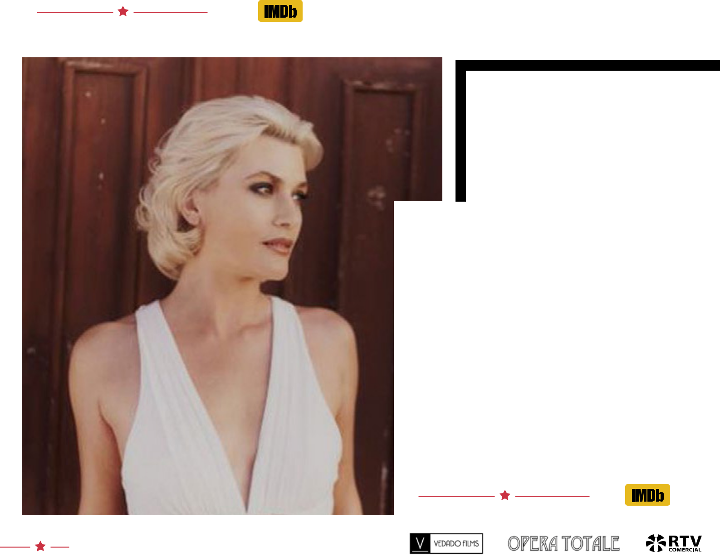

4 HAVANA KYRIE PRESS KIT 2019

KRIEMHILD MARIA SIEGEL

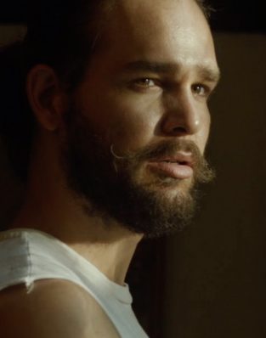

as HANNA KRAMER

Renowned Opera Singer and Vittorio’s Girlfriend.

Kriemhild Maria Siegel is well known German Soprano from Mühldorf. Her repertoire includes German, English, French, Italian and Spanish works of classical and contemporary music.

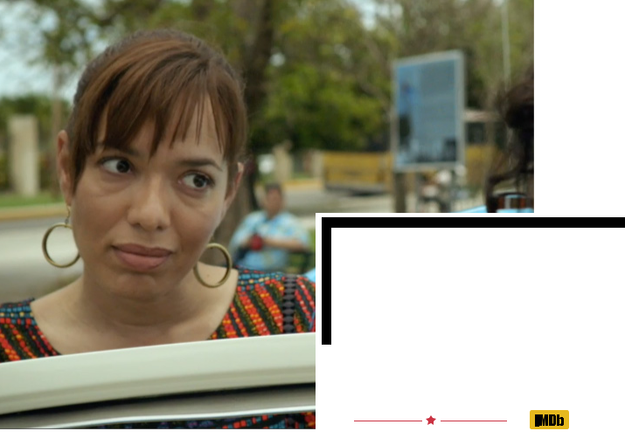

CHERYL
ZALDIVAR

as ROSITA
Deputy Director of the National Children’s Choir

Cheryl Zaldivar is a Cuban actress, previously

known for El Benny (2006)
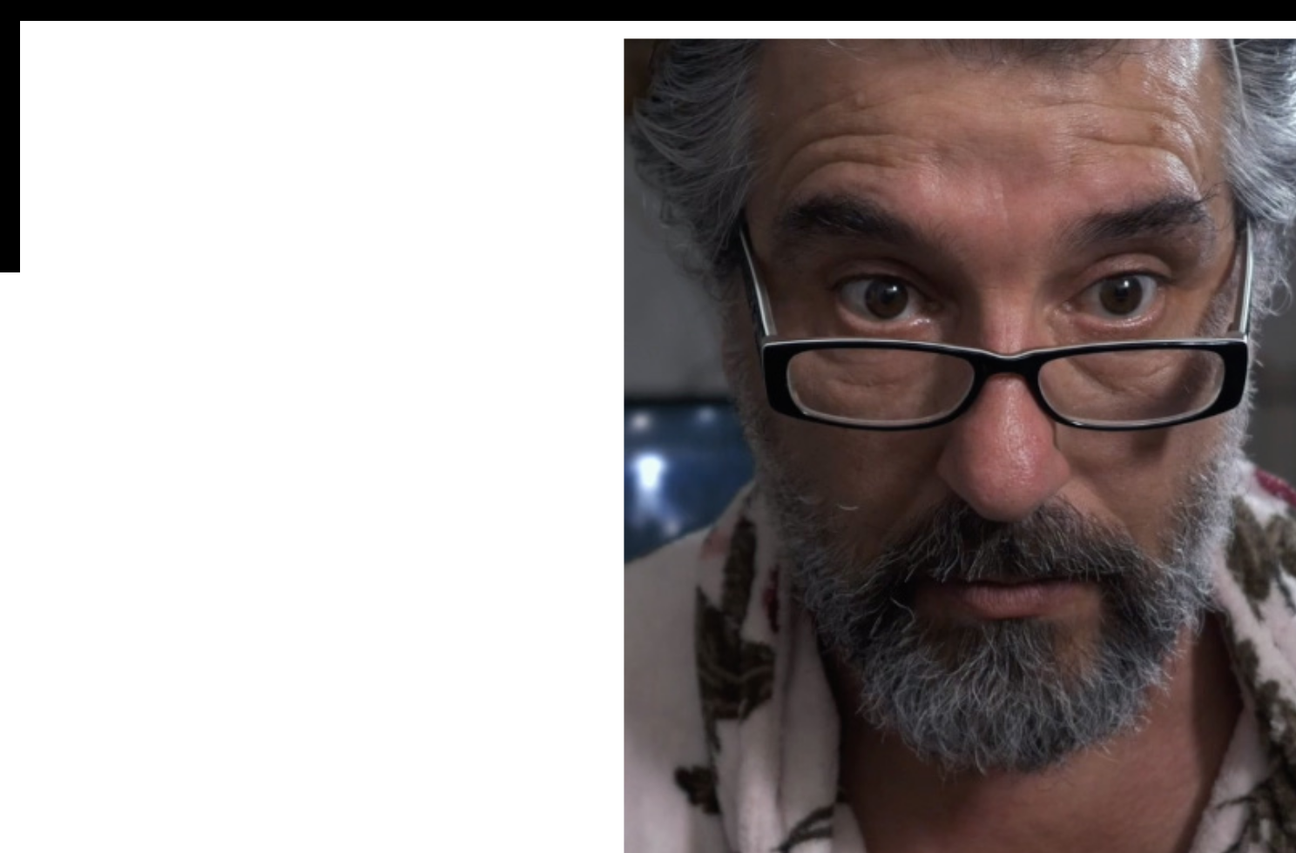

LUCA LIONELLO

as RAIMONDO

Maestro De Bellis’ artistic manager and loyal friend.

Luca Lionello is an actor from an Italian show business family. He is previously known for playing Judas in The Passion of the Christ (2004).

5 HAVANA KYRIE PRESS KIT 2019

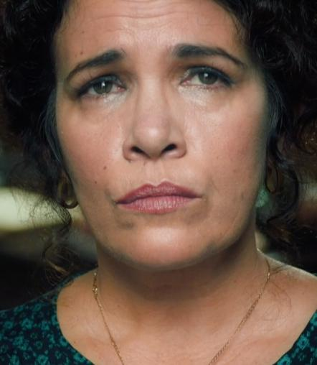

YERLIN
PEREZ

as VIRGINIA MENDOZA

‘Directora Mendoza’ - as the children call her - is the Head Chief of The National Children’s Choir.

Yerlín Pérez is a Cuban actress, previously known for Boccaccerias Habaneras (2014).
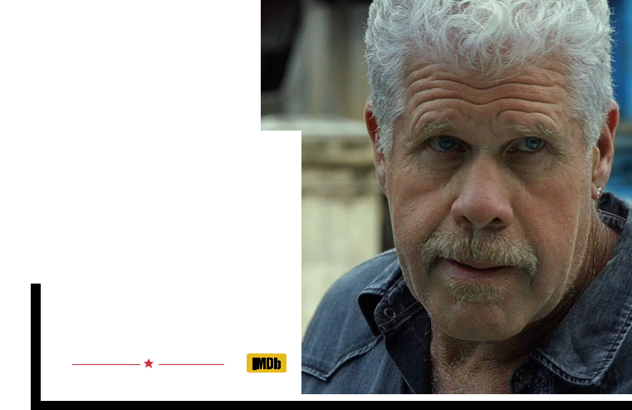

AND RON
PERLMAN

as HENRY

Isabel Orellanes’ husband and the only

true father figure Victor knew growing up...

Legendary actor Ron Perlman is known

for a myriad productions, including

from Quest for Fire (1981) and Hellboy

(2004) to Sons of Anarchy (2008).

6 HAVANA KYRIE PRESS KIT 2019

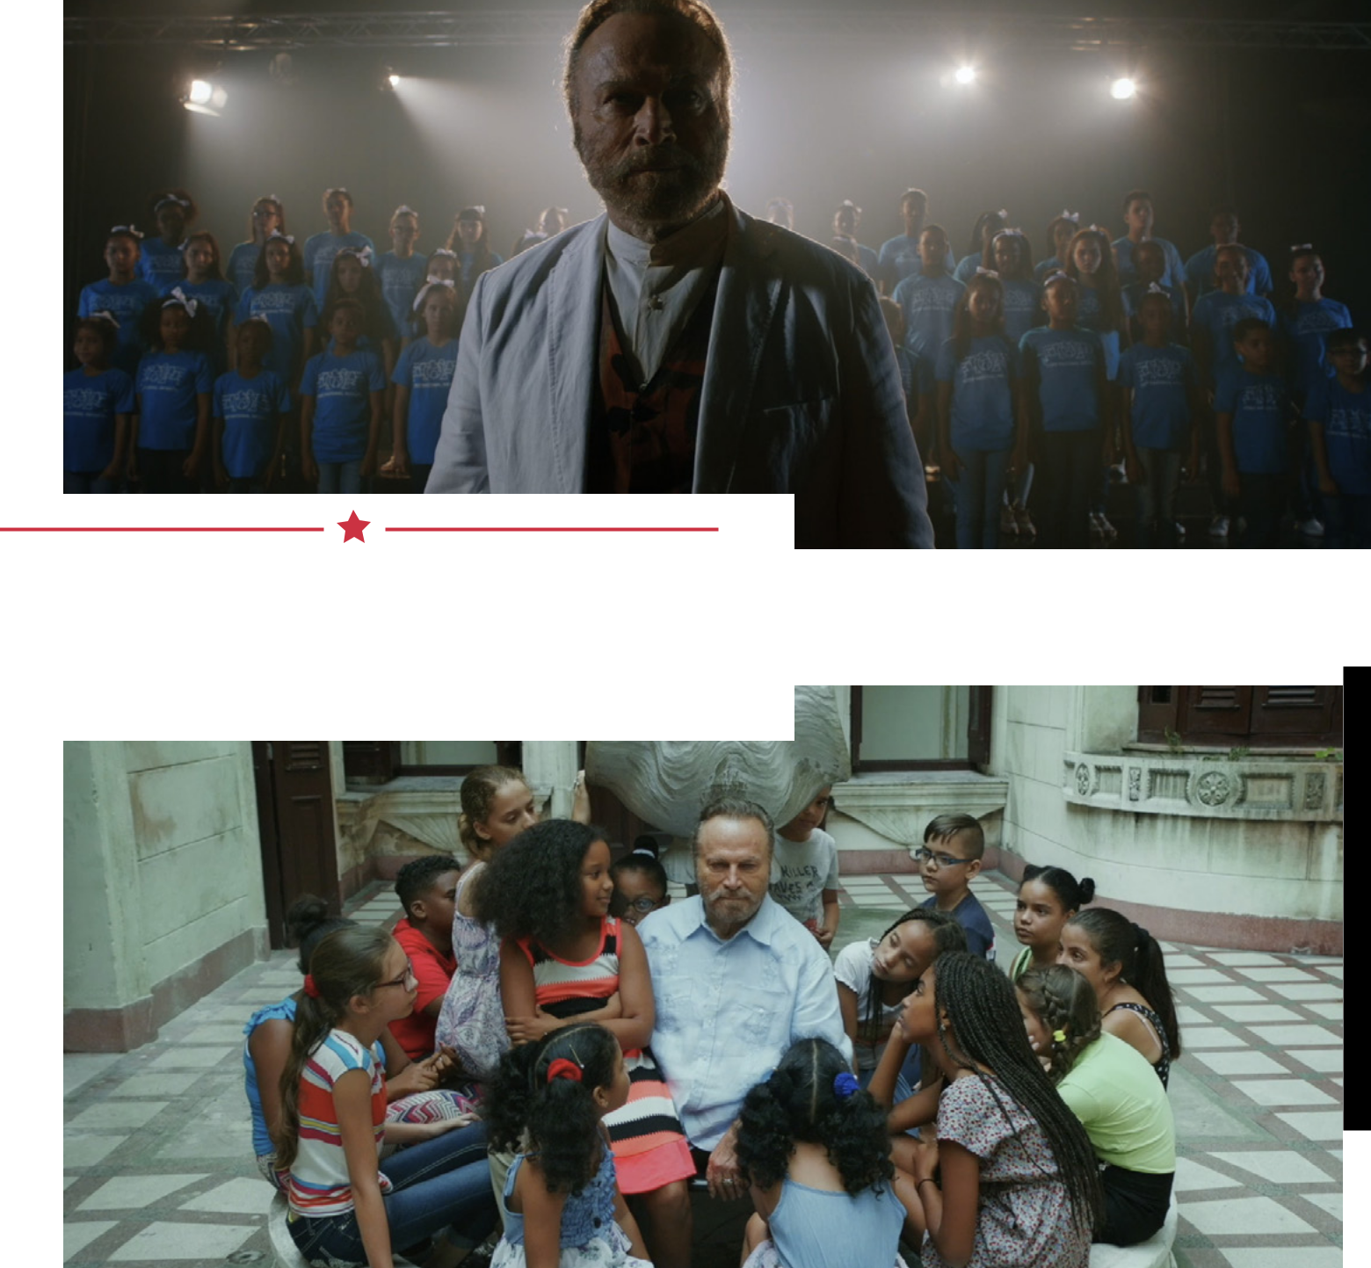

FEATURING THE

CUBAN NATIONAL CHILDRENS CHOIR
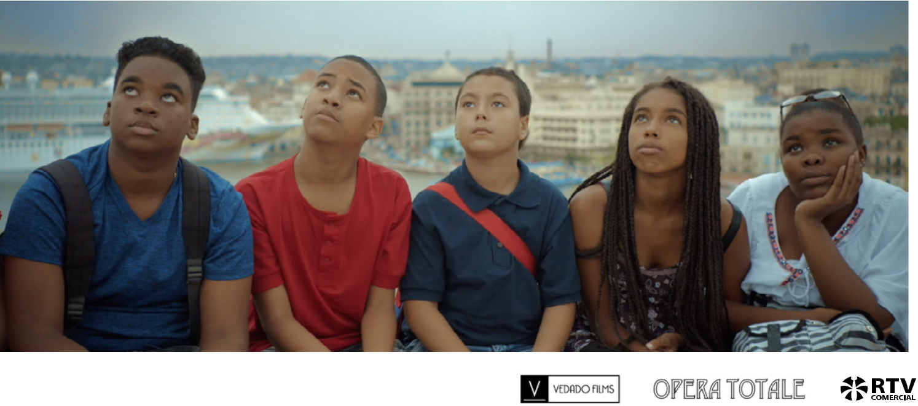

7 HAVANA KYRIE PRESS KIT 2019

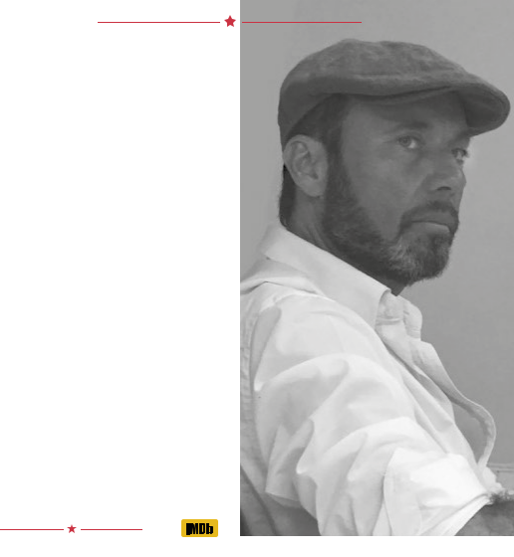
Directed by
PAOLO CONSORTI

Paolo Consorti is an Italian Director from San Benedetto del Tronto. He graduated from the Macerata Academy of Fine Arts

and begun his artistic career creating works that combined traditional pictorial practices with filmed and electronic media.

He stages his debut solo visual art exhibition at the Palazzo Ducale of Urbino. In 2008 Paolo is featured as one of Italy’s most promising young artists in the “Top Flash Art 100” list.

A calling to filmmaking is clear early on in his career, as he moves to collaborate on various films working alongside Oscar winner Sergej Fëdorovič Bondarčuk.

In 2012 he Directs his first feature film “Il Sole

Dei Cattivi” (The Sun of the Wicked), starring

Nino Frassica and Luca Lionello.

The following year Paolo Directs his second feature “Figli di Maam” (The Children of Maam), starring Luca Lionello, Franco Nero and Alessandro Haber, opening as a ‘Special Screening’ at the Sofia International Film Festival. In 2018 Paolo helms Cuban-Italian Co-Production HAVANA KYRIE - set for release in October 2019.

TECHNICAL DATA

TITLE

YEAR

COUNTRIES

FORMAT

GENRE

TRT

ASPECT RATIO

SOUND FORMAT

SHOOTING FORMAT

SHOOT LOCATIONS

HAVANA KYRIE

2019

Italy & Cuba

DCP / Colour

Family, Drama, Musical

103 minutes

1:1.85

5.1 Surround Mix

2K

Pesaro, Italy.

Havana, Cuba.


8


HAVANA KYRIE PRESS KIT 2019

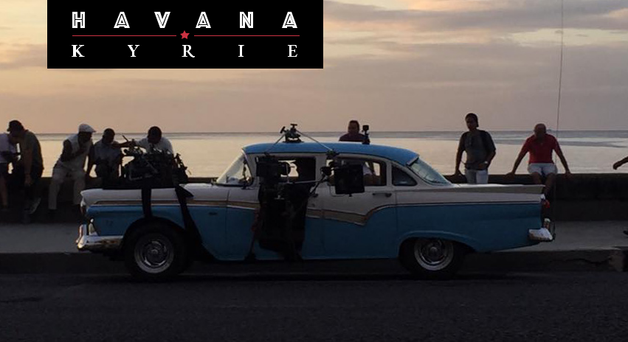

Produced by GABRIEL BERISTAIN & FRANCO NERO

CREW

DIRECTED BY Paolo Consorti

PRODUCED BY Gabriel Beristain &

Franco Nero

CINEMATOGRAPHER Dario Germani

SCREENWRITER Alfredo Mazzara

STORY BY Paolo Consorti,

Alfredo Mazzara

COMPOSER Danilo Aielli

CO-PRODUCERS Franco Faggiani,

Gianni Gasperini

& Sacha Rodriguez

EDITOR Niccolò Notario,

CO-EDITOR Sasha Whitehouse

SOUND DESIGNER Massimiliano Baccella

ORIGINAL MUSIC Lizt Alfonso, Danilo Aielli,

PROD. DESIGNER Maikel Alejando

Gonzalez Paez

S’VISING PROD. DESIGNER Gianni Quaranta

COSTUME DESIGNER irena Reguera Marquez

MAKE UP BY Pavel Marrero

POST-PRODUCTION S’VISOR Claudio D’Elia

POST-PRODUCTON FACILITY Image + Light

Rome, Italy

EXEC. PRODUCER Sacha Rodriguez

EXEC. PRODUCER RTV

Adriana Moya Gonzalez

PROD. COMPANIES Opera Totale SRL,

RTV Comercial

Vedado Films USA LLC

- HAVANA KYRIE PRESS KIT 2019

CONTACT

Gabriel Beristain or

Sacha Rodriguez

Vedado Films LLC

1-VEDADO FILMS (1-833-236 3456)
info@vedadofilms.com

10 HAVANA KYRIE PRESS KIT 2019

